Scenario 3: launch a public website in public subnet. [public subnet + internet Gateway]
Step 1: lets launch a website from Linux machine.
Step 2: go to ec2 console > Launch a instance.
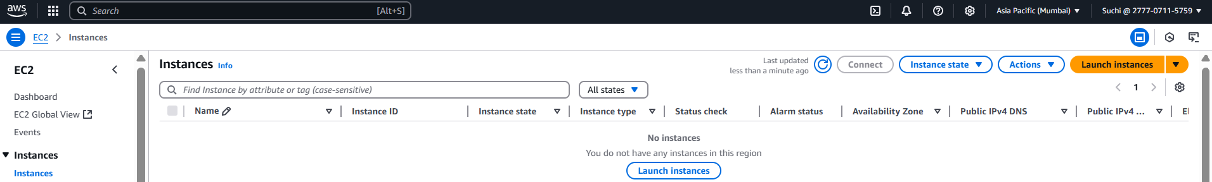
Step 3:
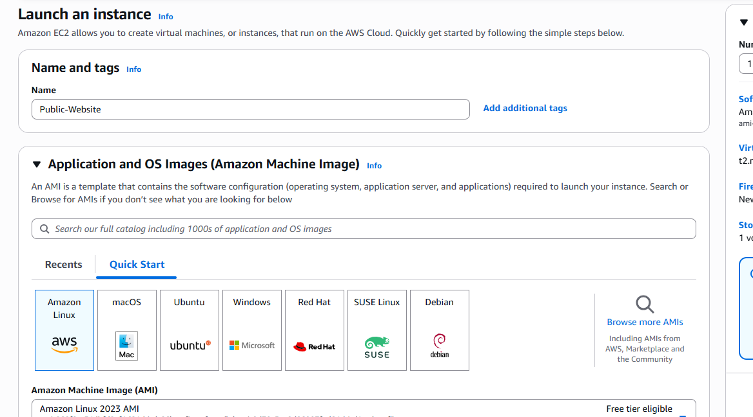
Step 4:
- Select the VPC which we have created
- Select the public subnet which we have created
- Auto-assign public Ip - enable
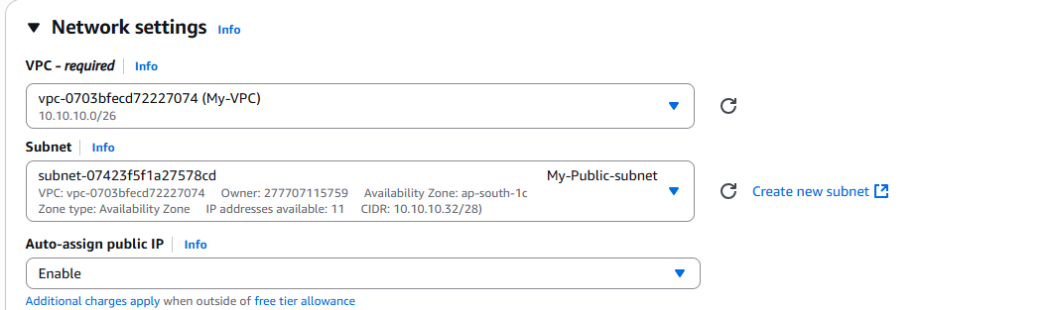

Step 5: lets assign a manual primary IP for an instance, instead of auto.
Usable IP for public subnet are : 10.10.10.36 – 10.10.10.46 (11 usable IPs)
Let’s choose 10.10.10.40
Step 6: to assign this IP to instance > click on advanced network settings.
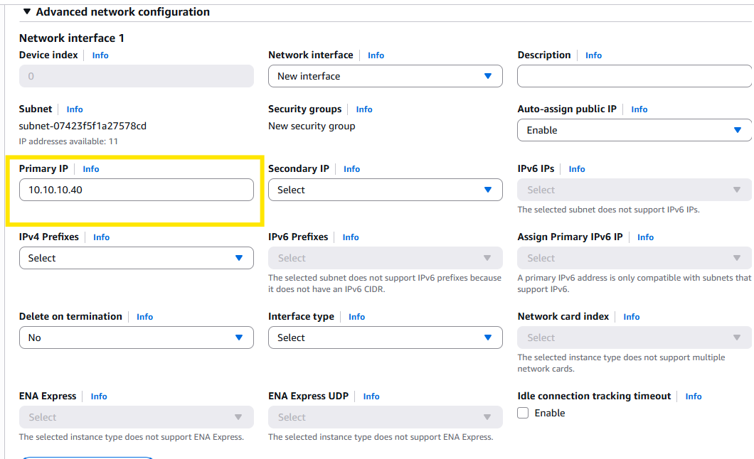

Step 7: click on the Advance details below and add the user data to it.
#!/bin/bash
# Use this for your user data (script from top to bottom)
# install httpd (Linux 2 version)
yum update -y
yum install -y httpd
systemctl start httpd
systemctl enable httpd
echo "<h1>Hello World from $(hostname -f)</h1>" > /var/www/html/index.html
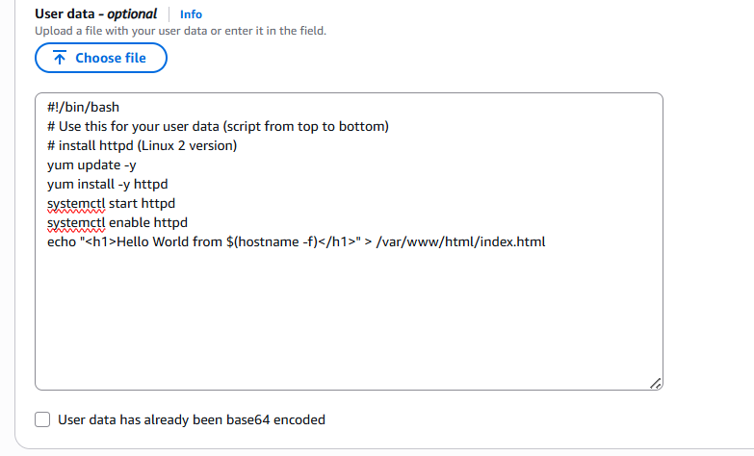

Step 8: lets validate.
We could see that it’s not launching.
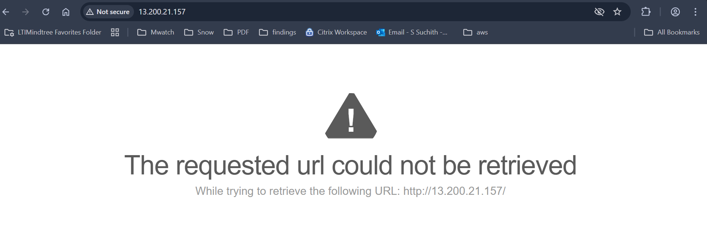
Let’s allow inbound rule to an ec2 for http port from anywhere
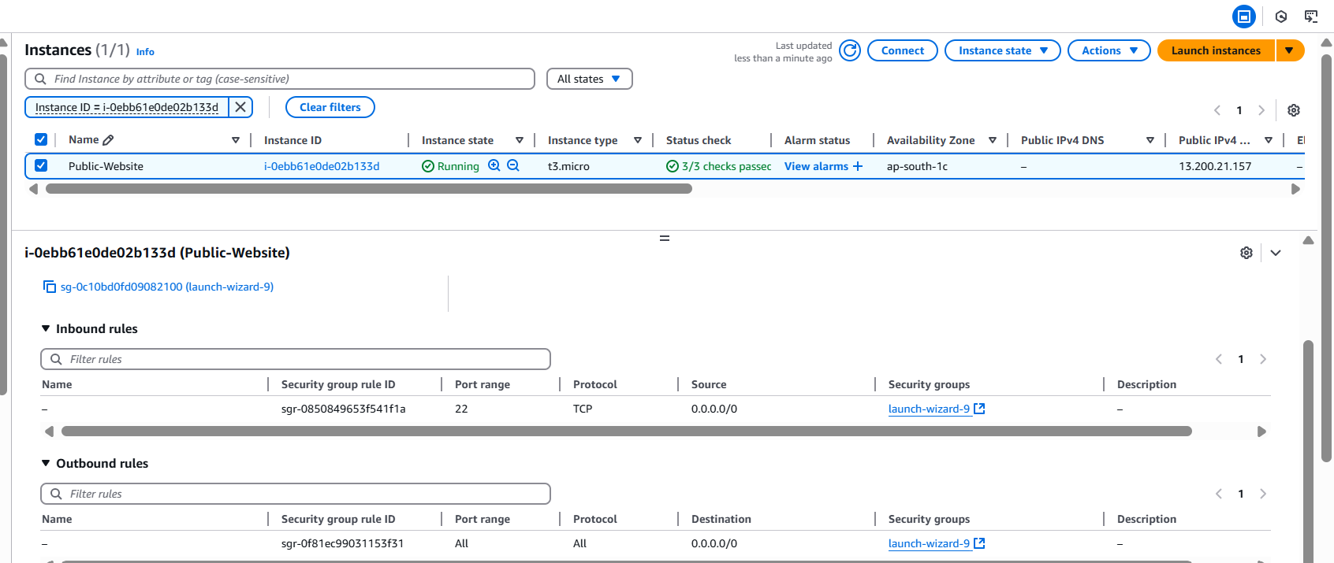

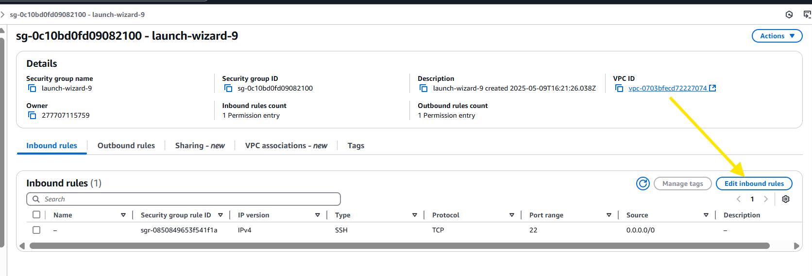
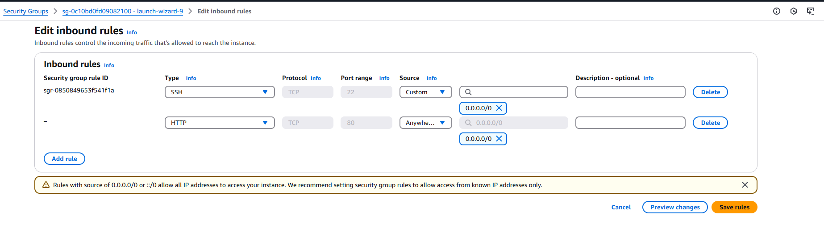
Step 9: select validate again.
Still, we could see same issues.
Further we could see that this server is hosted in public subnet, but it does not have an internet gateway.
Let’s attach internet gateway to public subnet
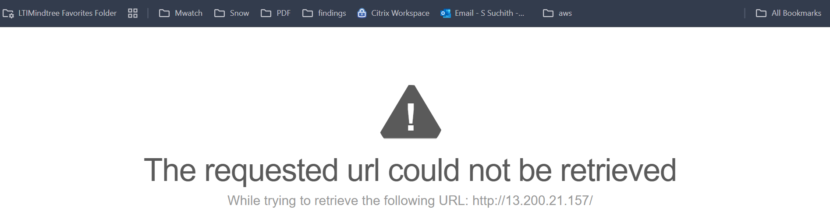
Step 10: go to VPC , in the left side panel > select internet gateway
You can either create a new one and attach to VPC or select the default one and attach to vpc.
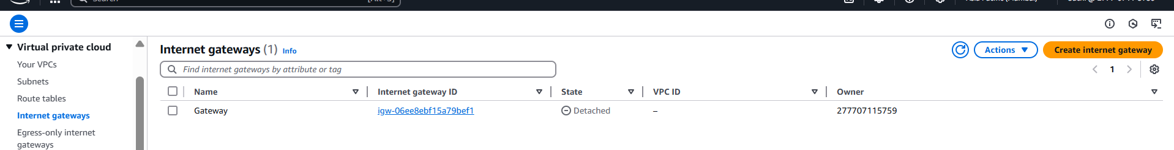
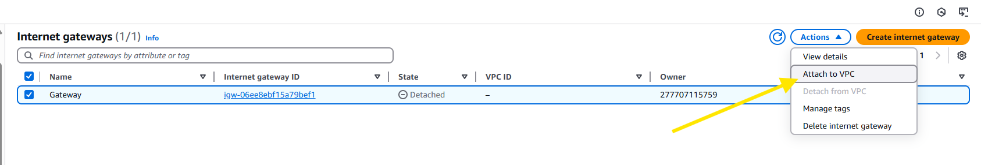
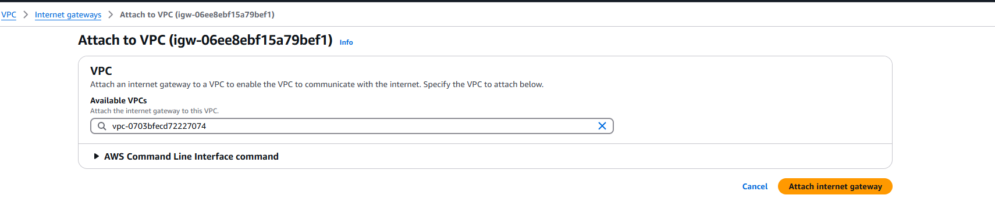
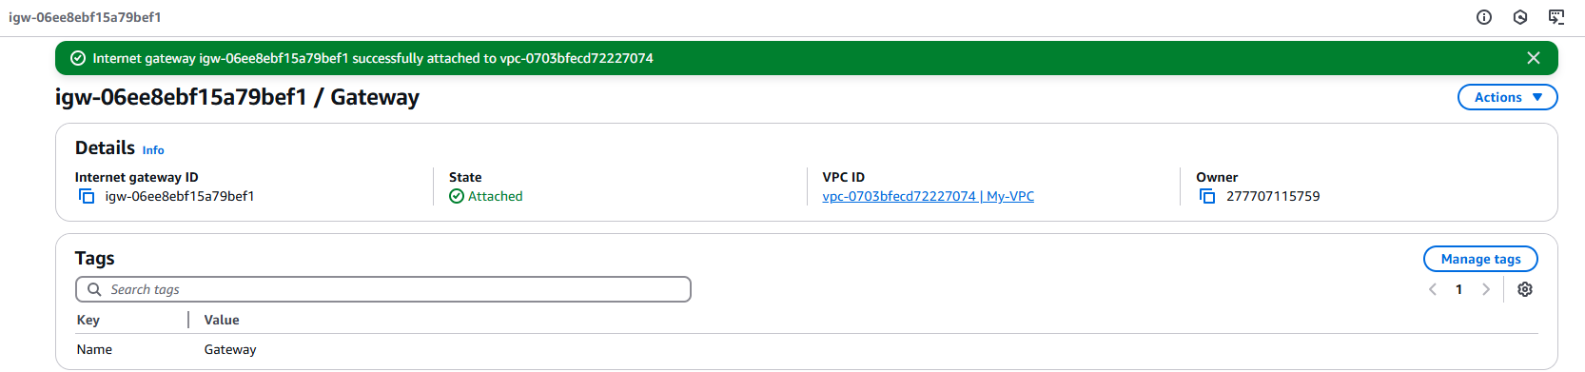

Step 11: even though our VPC is attached to internet gateway we don’t have an internet access.
We need to specify the route via route table.
Let’s create a route table – public route table and private route table.
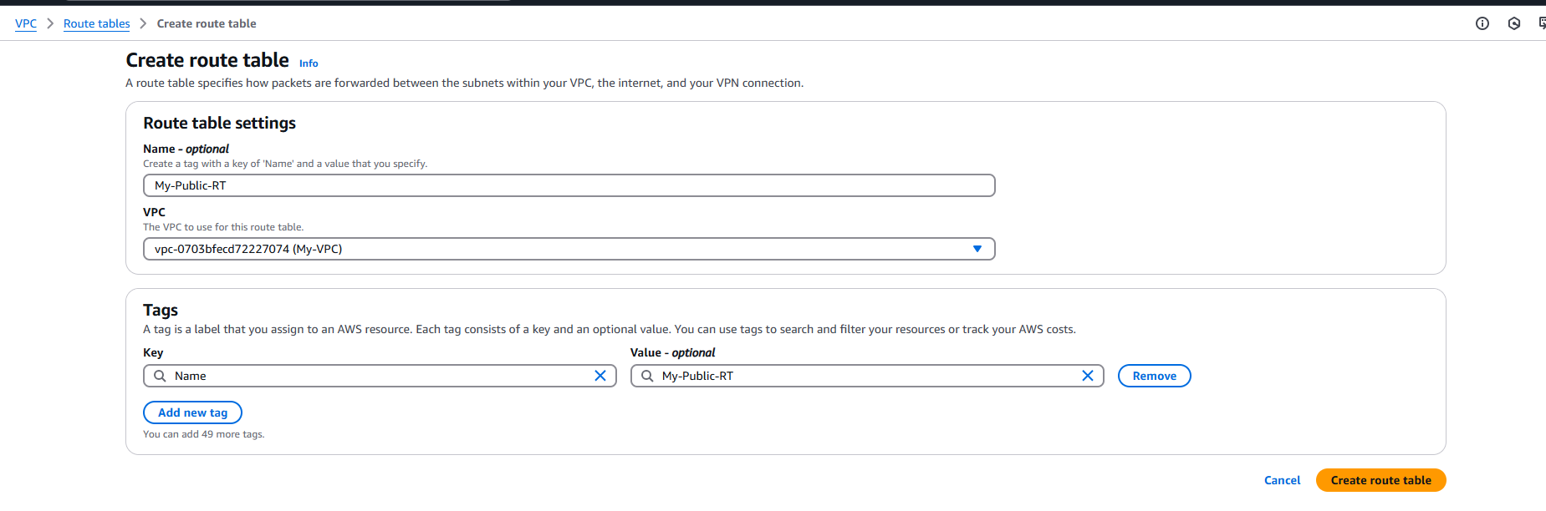
Follow the same for private.
Step 12: lets create an route.
For public route table it should to through internet gateway.
And for private let’s leave it as it is. (local)

Step 13: select public route table
Scroll down and click for Routes.> edit routes
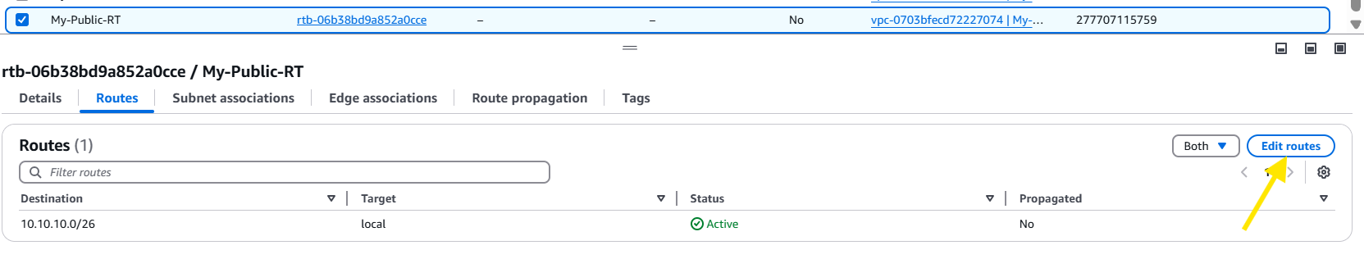
Step 14:
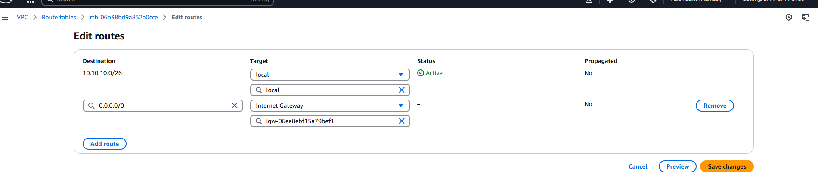
Step 15 : lets validate. By again launching a site.
Still no results.
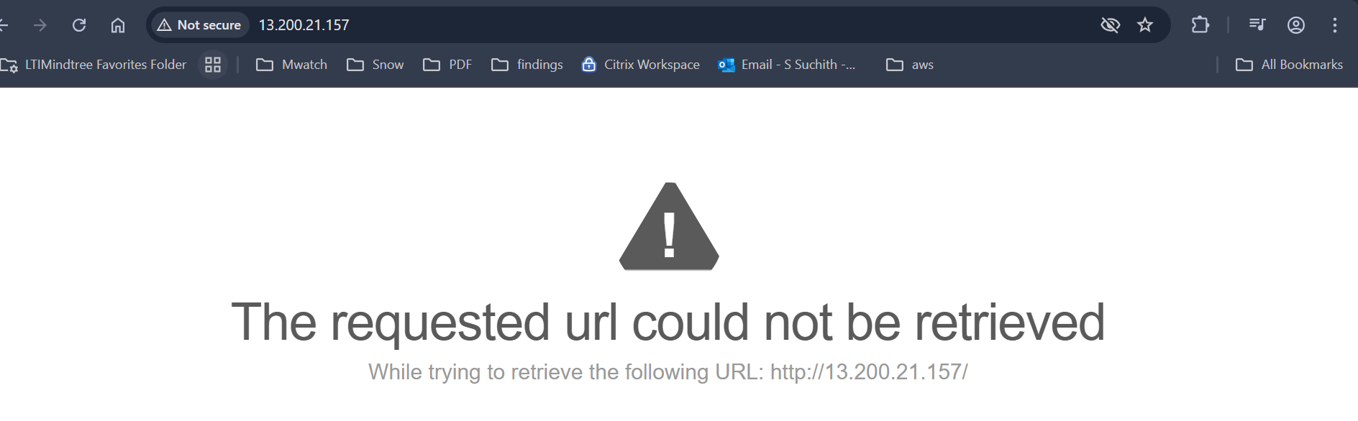
Step 16: go to subnet > select public subnet and validate for the route table
We could notice that route is in default-RT , lets edit and specify the public-RT.
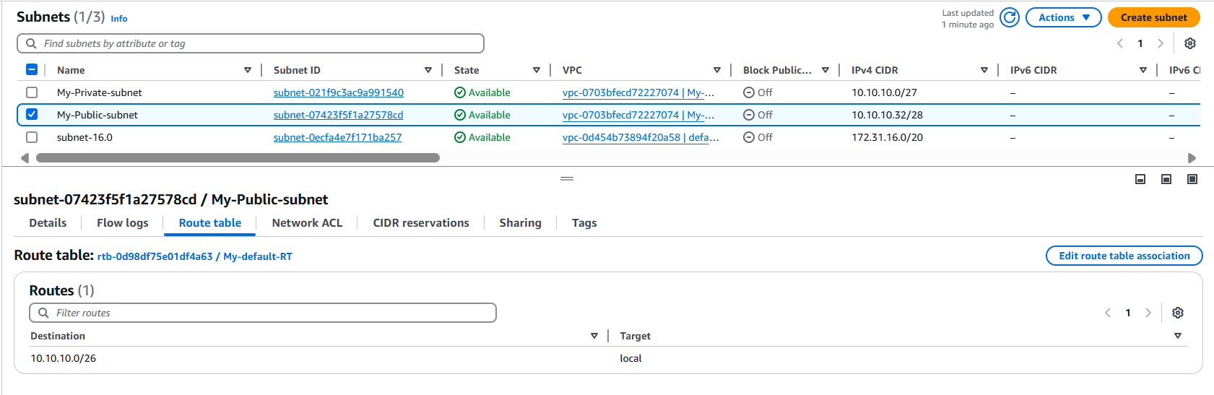
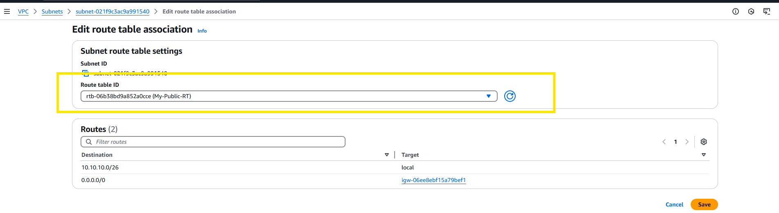
Step 16 : lets validate. By again launching a site.
Success.

